# Project Introduction

Water quality refers to the chemical, physical, biological, and imaging characteristics of water. it's a live of the condition of water relative to the wants of 1 or a lot of organic phenomenon species, or to any human would like or purpose. it's most often utilized by respect to a group of standards against that compliance, usually achieved through treatment of the water, is assessed. the foremost common standards accustomed assess water quality relate to health of ecosystems, safety of human contact, and drink. Water quality contains a large impact on offer|water system|water|facility|installation} and oft determines supply choices.  
  
Environmental water quality, conjointly referred to as close water quality, relates to water bodies like lakes, rivers, and oceans. Water quality standards for surface waters vary considerably because of completely different environmental conditions, ecosystems, and meant human uses. hepatotoxic substances and high populations of bound microorganisms will gift a jeopardy for non-drinking functions like irrigation, swimming, fishing, rafting, boating, and industrial uses. These conditions may additionally have an effect on life, that use the water for drinking or as a surround. in step with the Environmental Protection Agency, water quality laws usually specify protection of fisheries and recreational use and need, as a minimum, retention of current quality standards.  
  
There is some need among the general public to come water bodies to pristine, or pre-industrial conditions. Most current environmental laws specialise in the designation of specific uses of a water body. In some countries these designations allow some water contamination as long because the specific style of contamination isn't harmful to the selected uses. Given the landscape changes (e.g., development, urbanization, clearcutting in wooded areas) within the watersheds of the many fresh bodies, returning to pristine conditions would be a big challenge. In these cases, environmental scientists specialise in achieving goals for maintaining healthy ecosystems and should think about the protection of populations of species and protective human health.

# Analysis OBjectives

Here are the list of question whose analysis which be given below..

1. Comparison between EQR Value and Normalised Value
2. What is the individual contribution of data from the different data sources
3. What are the different dates on which life span was revised
4. What are the different types of observed Property Determin and Code
5. What is the Minimum, mean, and maximum EQR value
6. Standard deviation of the EQR Values
7. EQR classification for different number of sites

# Data Acquisition and Cleaning

**Code to read the data from Excel / CSV / HTML.**

To read the dataset in csv format, we will load it into Pandas data frame but first let’s import the pandas library and set an alias by typing **“import pandas as pd”**. After importing the library with the alias **“pd”**, let us load the .csv file using the following line of code:

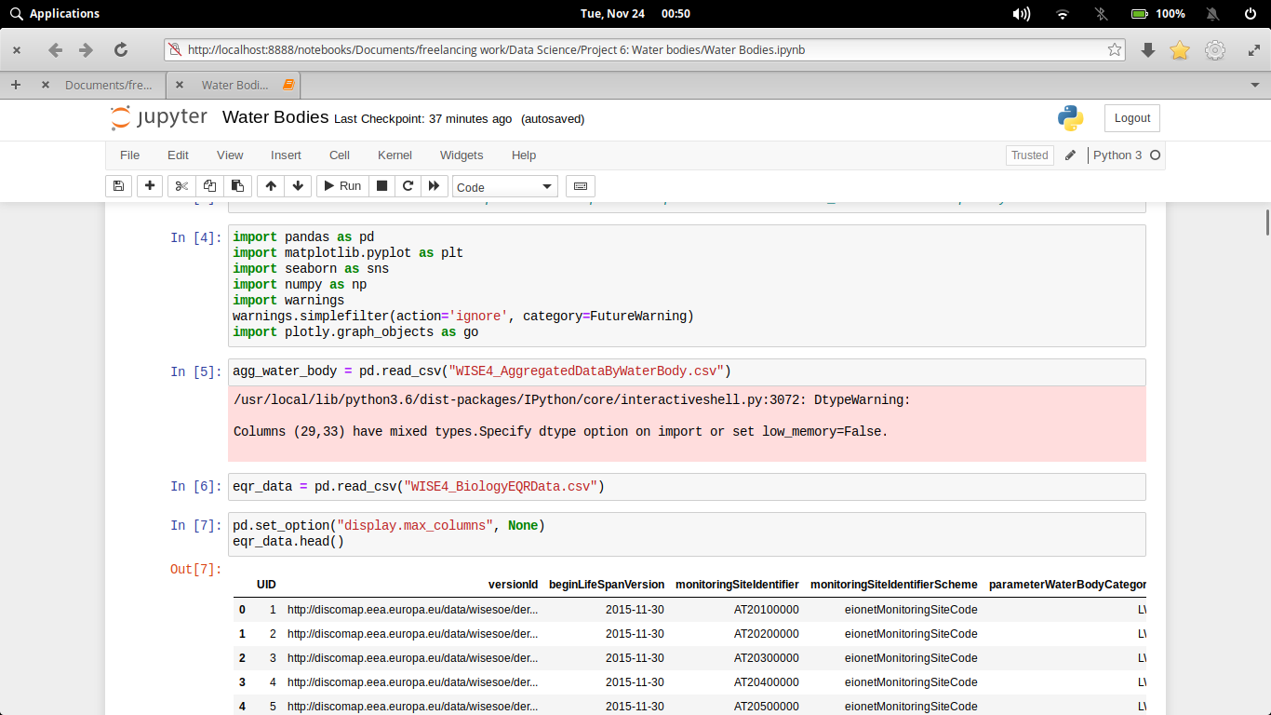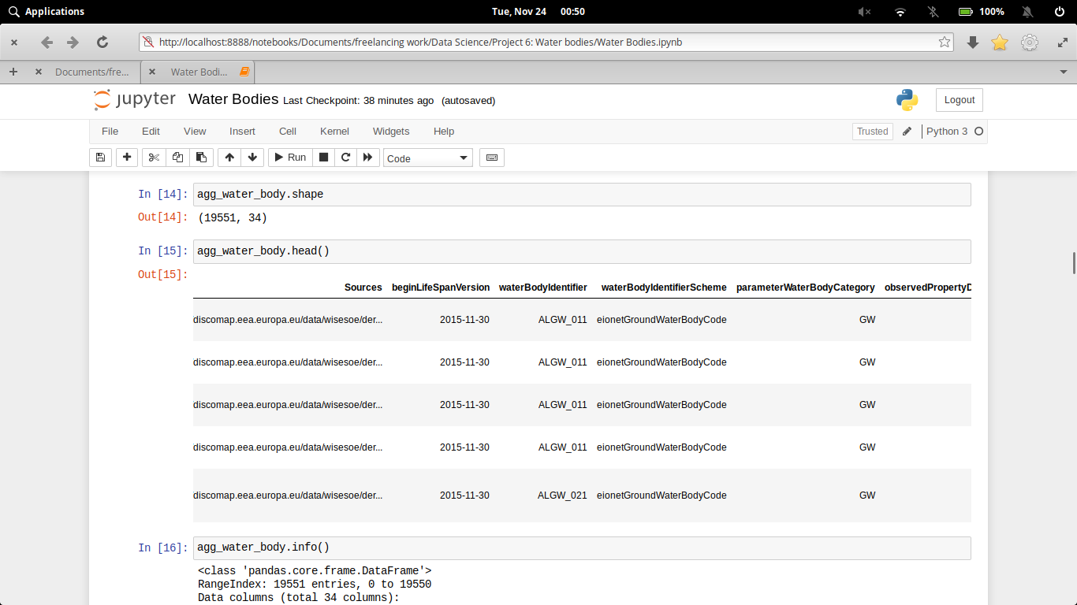Here we have import our csv files and read through pandas library.

Here the csv file can be read through (Pandas library) and store in two different dataframes. The Dataframe can be shown through **.head()**. The number of rows we want to show, that number we have to pass in head parentheses as an argument.

Now if we want to describe our dataframe for our better understanding to know the stats. and other parameter that our dataset should follow

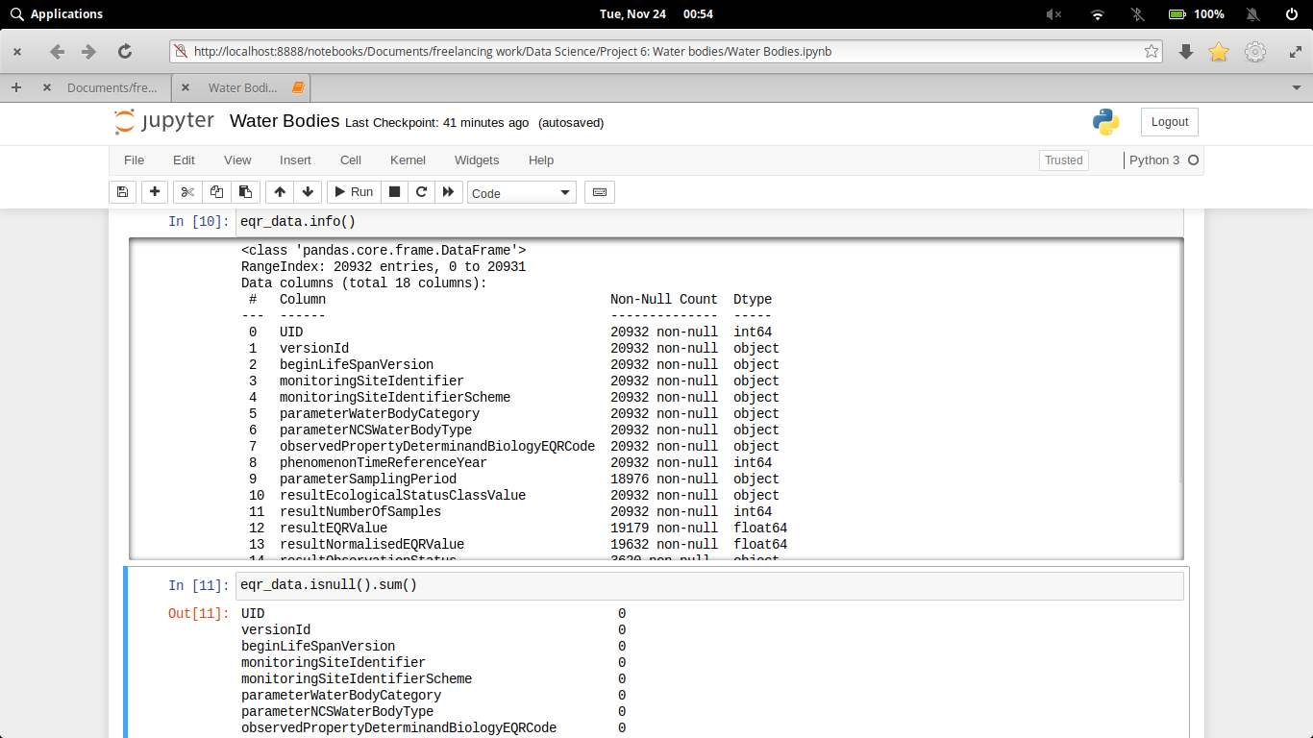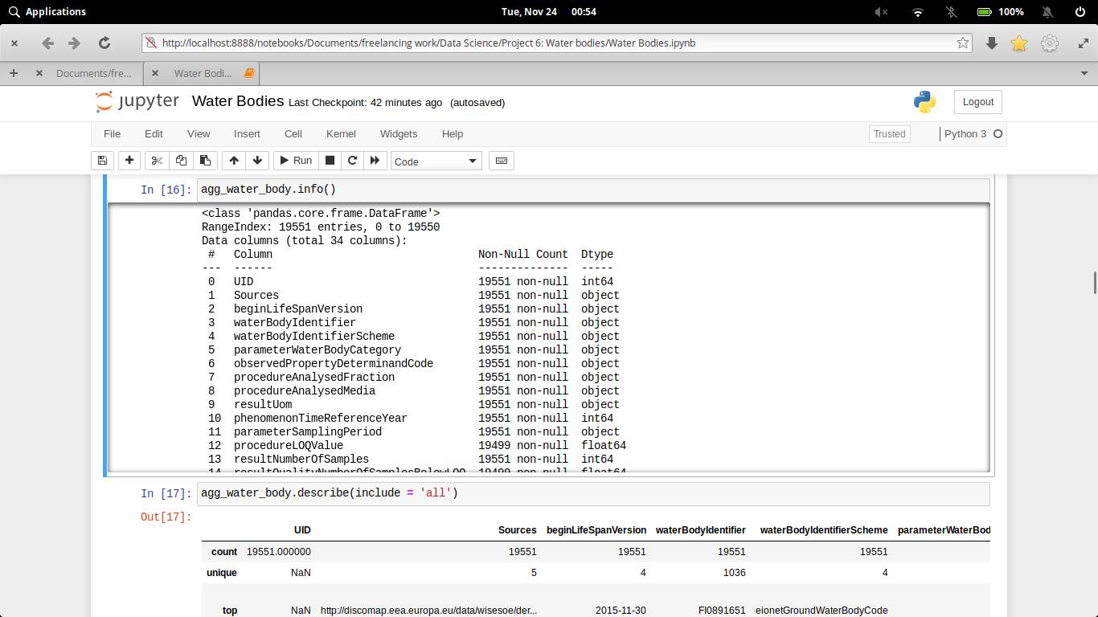**Clean the unnecessary data, by removing, replace the missing data and renaming the columns.**

Dataset generally contains some null value, which is generally caused by misplacing some values. So its necessary to clean this mess from our dataset for better visualization

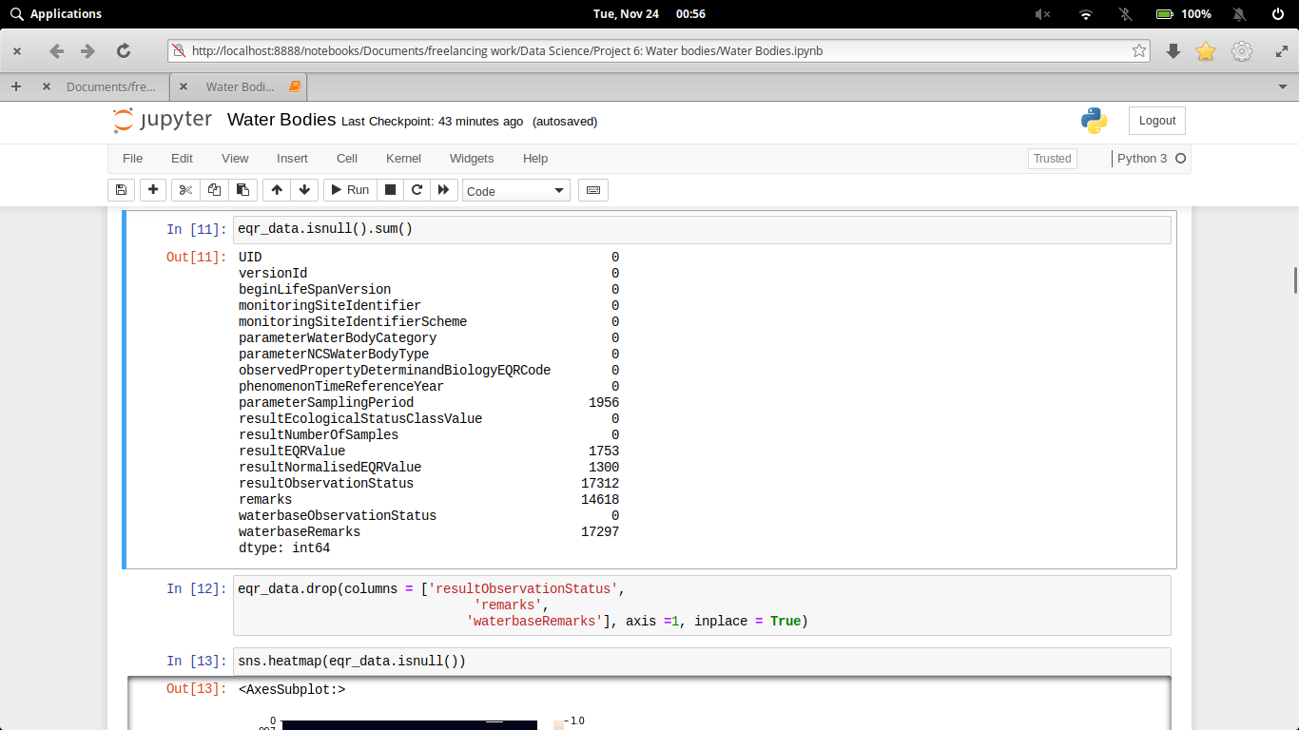

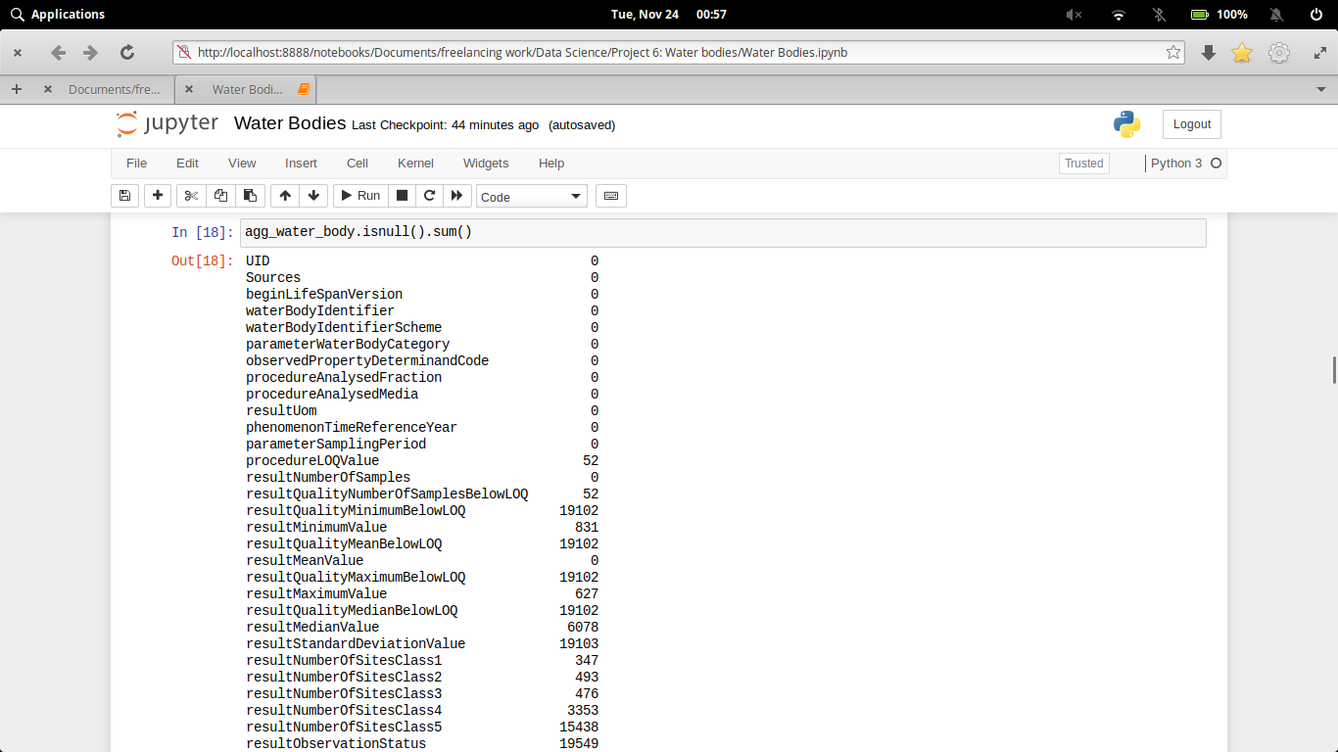

In the above diagram we see that some of the columns of this datasets contains null value.

In the process of data cleaning we first drop the columnswhich contains atmost null value. Then subsequently we fill the other null values column with its mean value or 0, so that the values will not much more effect. Finally after all process our heatmap diagram shows that our datasets is almost clean.

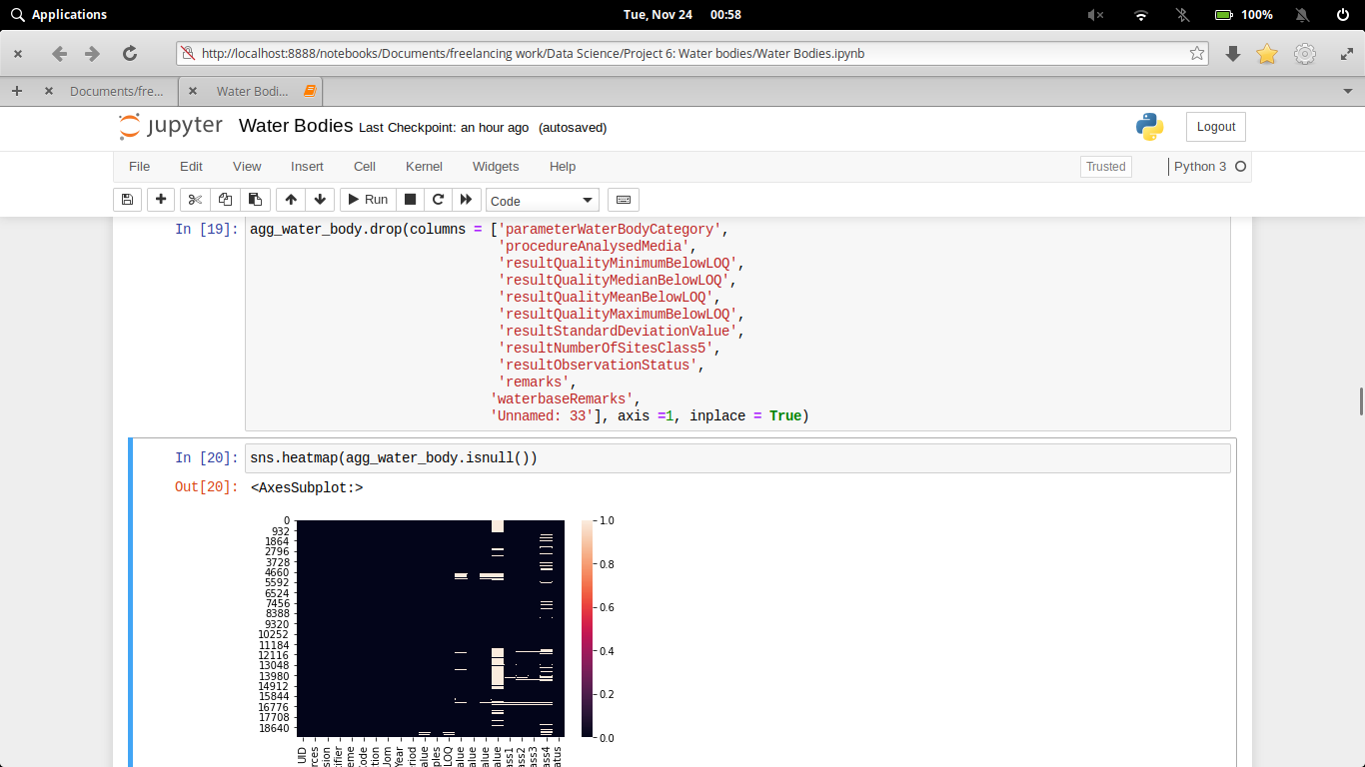

**why data clean needed (for your data)**

Data cleansing or scrubbing or appending is the procedure of correcting or removing inaccurate and corrupt data. This process is crucial and emphasized because wrong data can drive a business to wrong decisions, conclusions, and poor analysis, especially if the huge quantities of big data are into the picture.

# Data and Exploratory Analysis

**Code and its output with Explanation**

1. **Comparison between EQR Value and Normalised Value**

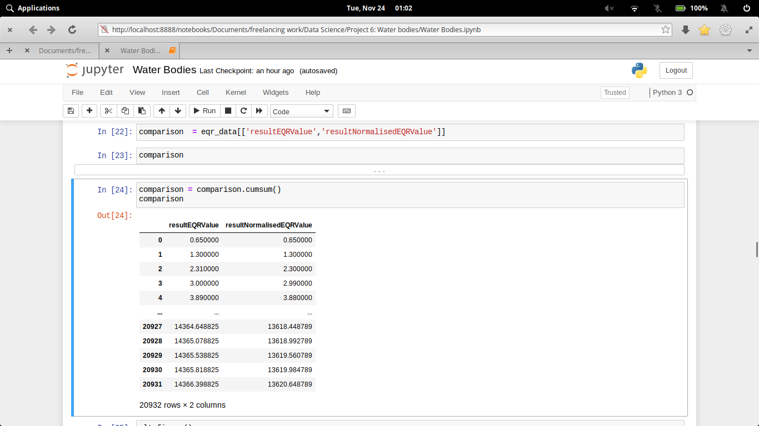

Normalization is the method used to standardize the range of features of data. Here we have compared our EQR value with its normalized form.

1. **What is the individual contribution of data from the different data sources**

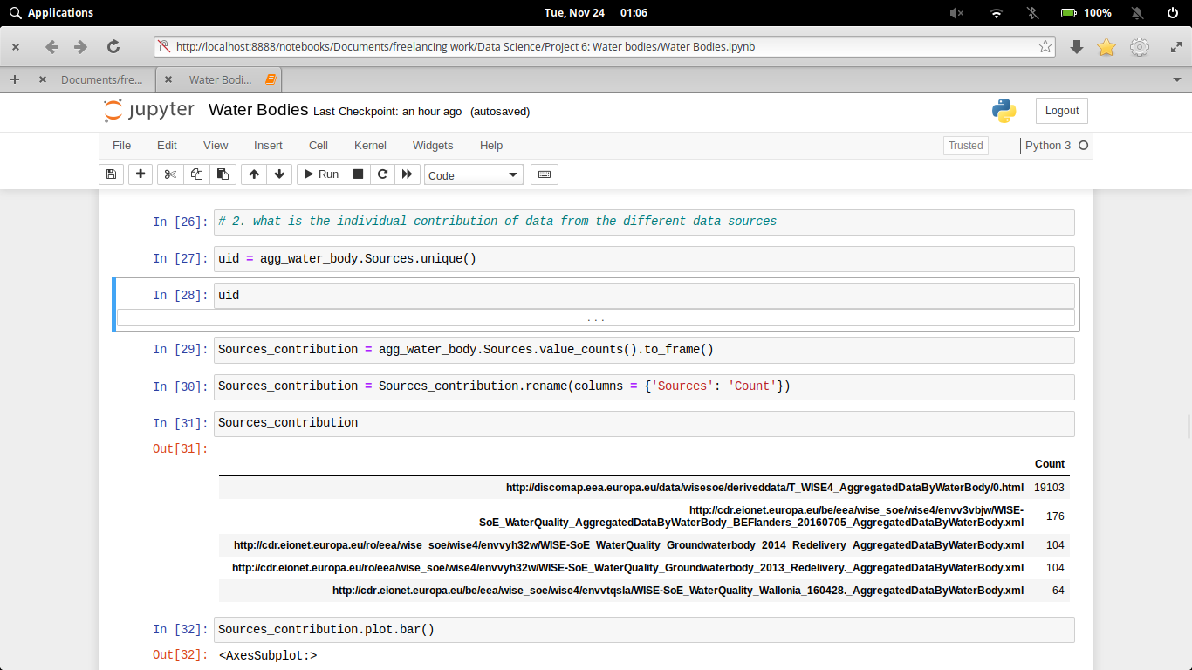

Here our main motto is to know which sources has contributed in this database.

1. **What are the different dates on which life span was revised**

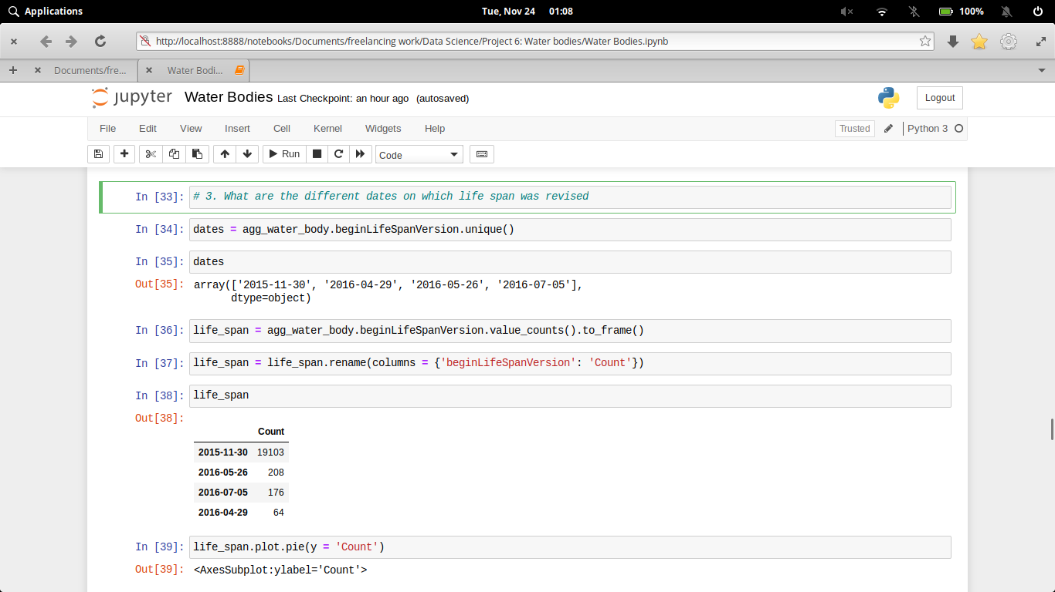

Sometimes, the quality of water bodies due to some environmental conditions or some human activities can infer, so here, we have examined on which dates, these results were revised.

1. **What are the different types of observed Property Determin and Code**

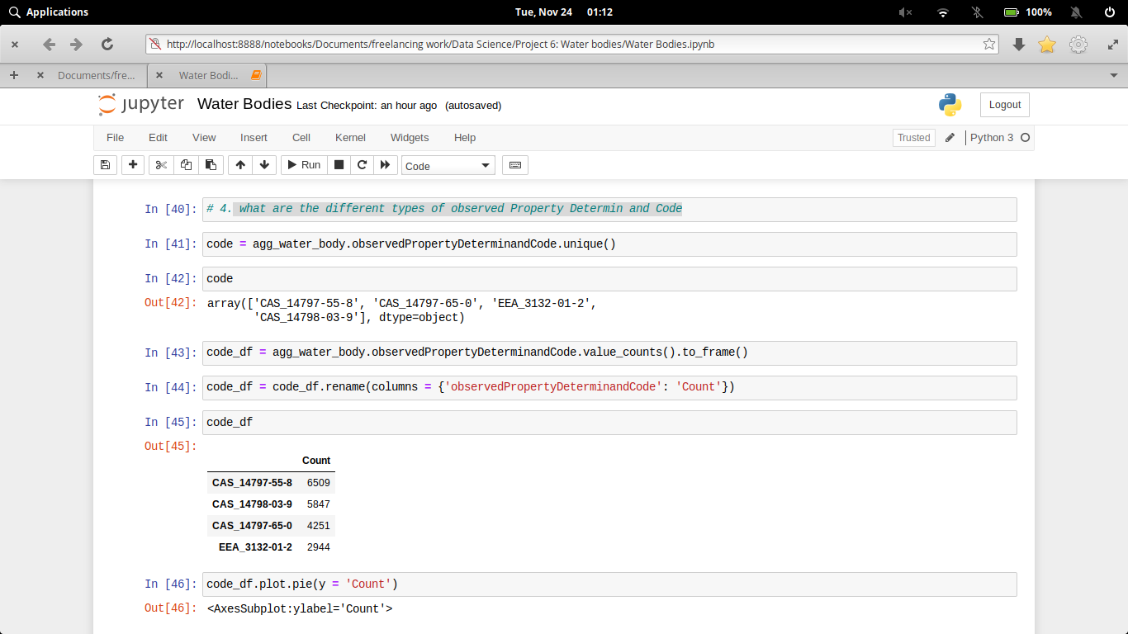

1. **What is the Minimum, mean, and maximum EQR value**

EQR Value is used to determine the quality of water bodies. So, in order to judge a quality, mean, median and mode of its max and minimum value is very helpful.

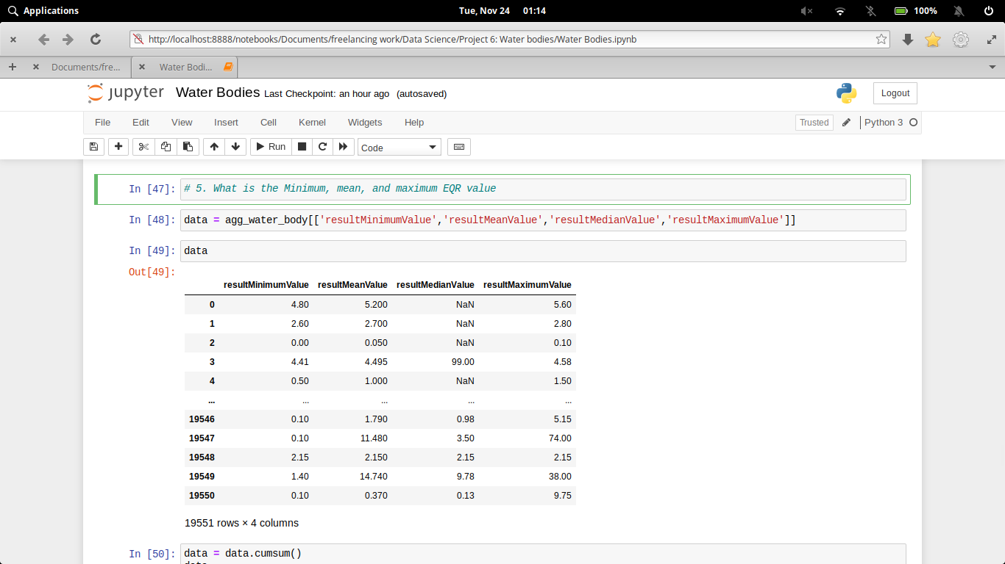

1. **Standard deviation of the EQR Values**

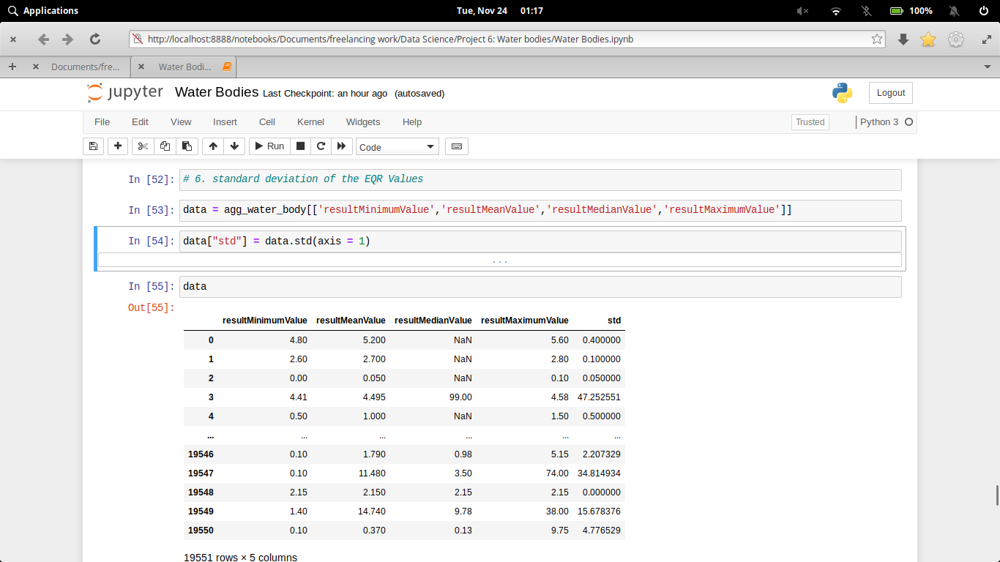

1. **EQR classification for different number of sites**

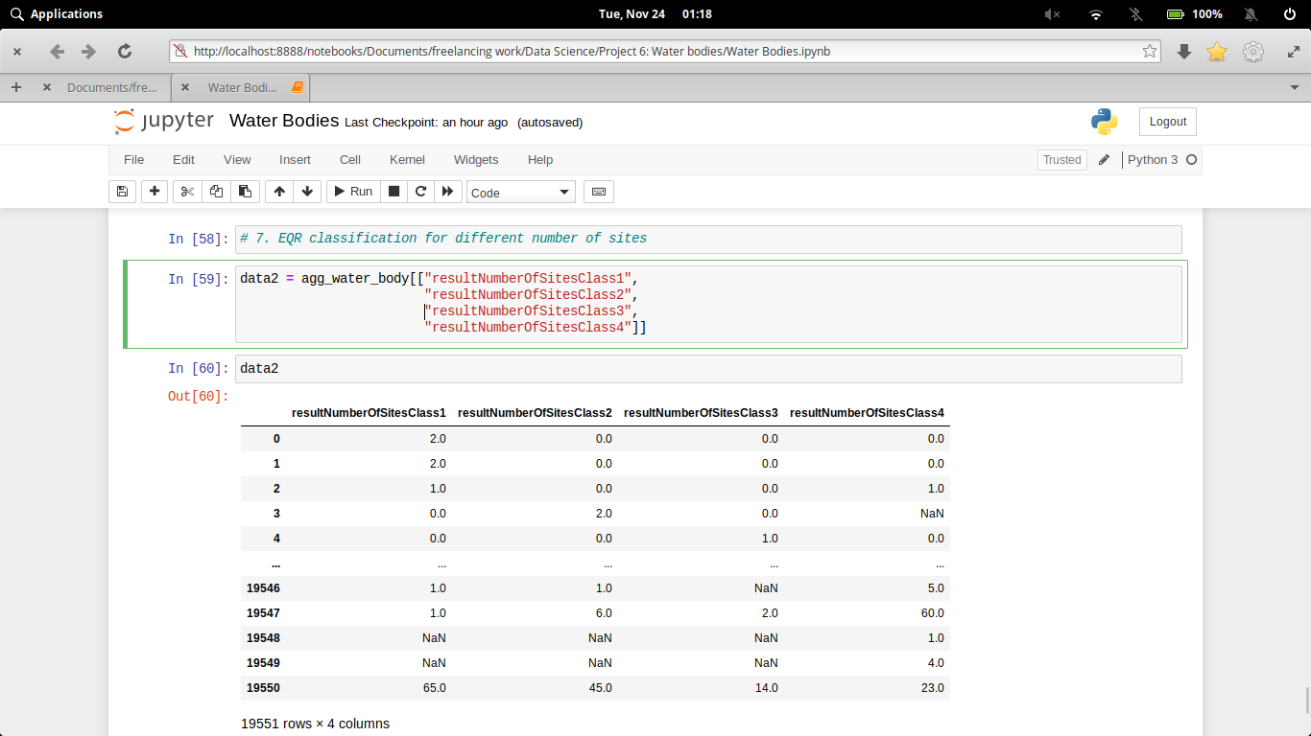

# Data Analysis – Visualization

**Code and its output with visualization**

1. **Comparison between EQR Value and Normalised Value**

**Code:-**

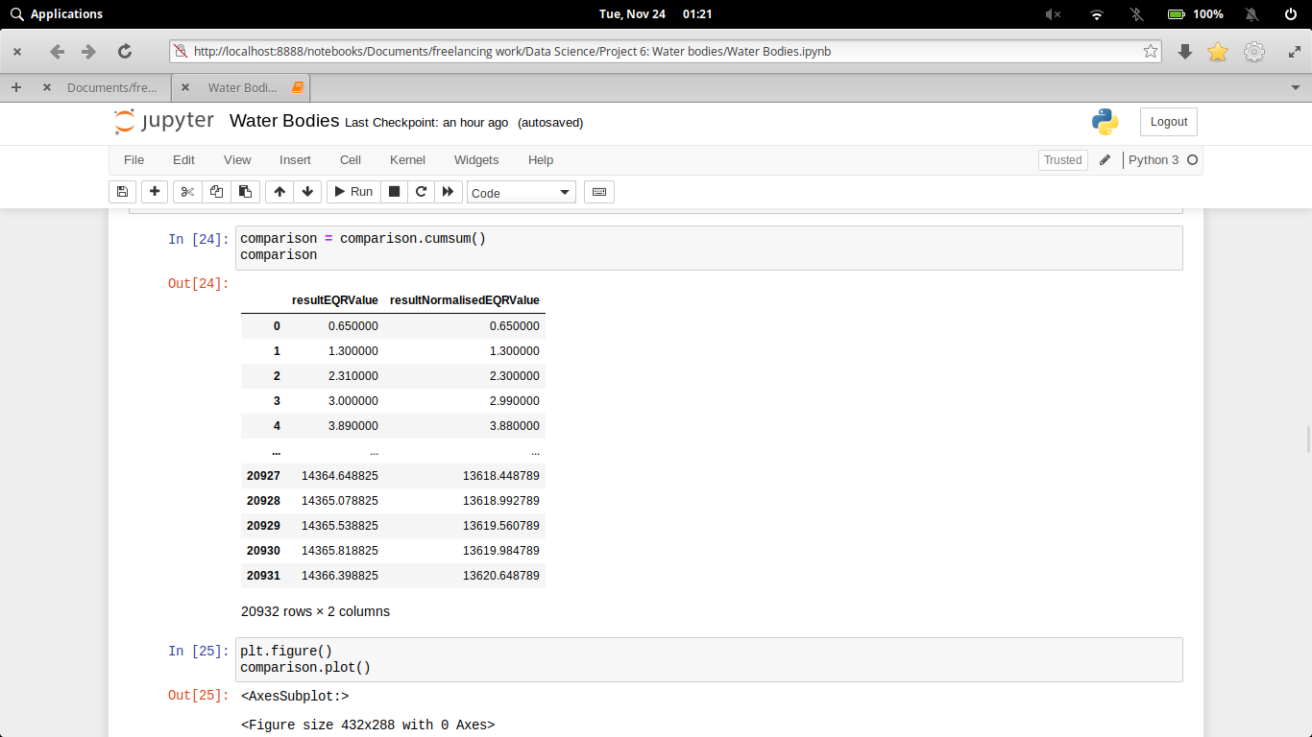

**Output:-**

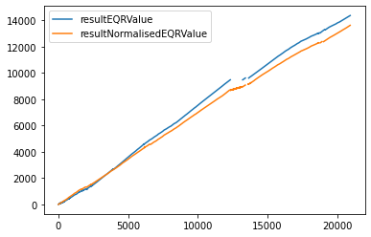

1. **What is the individual contribution of data from the different data sources**

**Code:-**

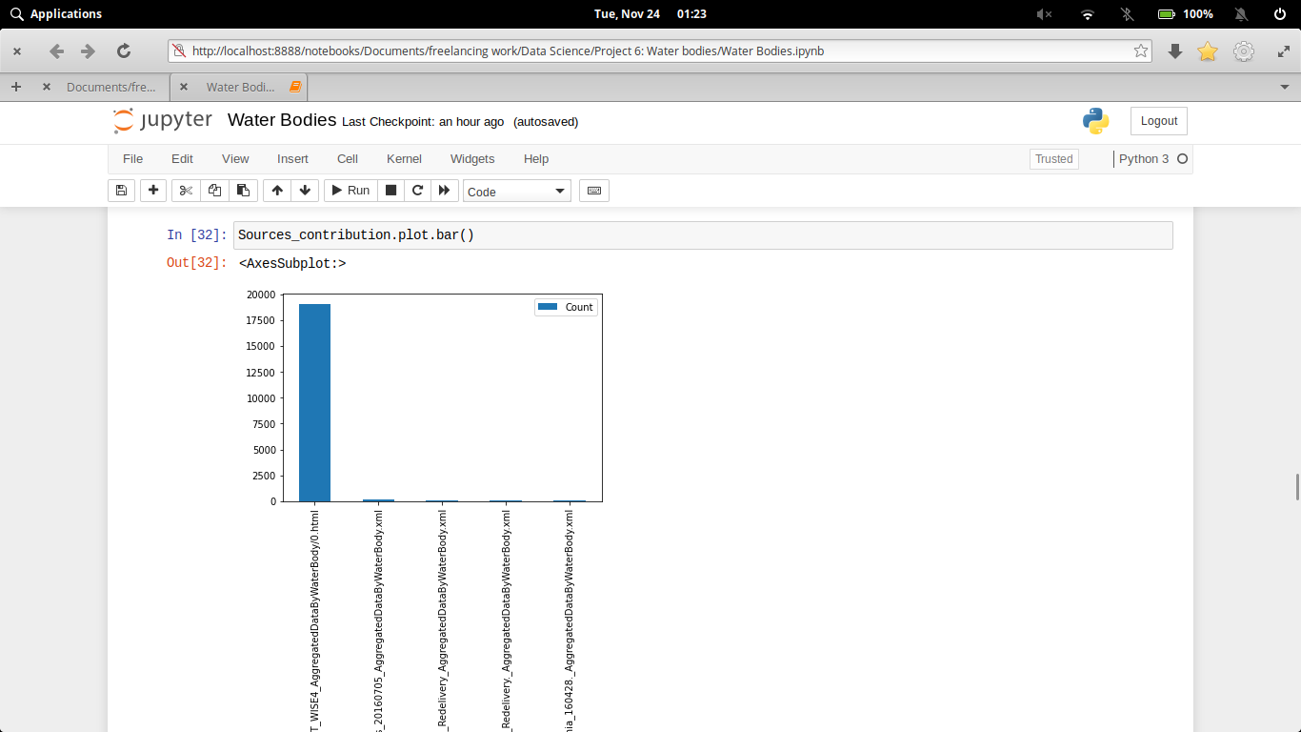

**Output:-**

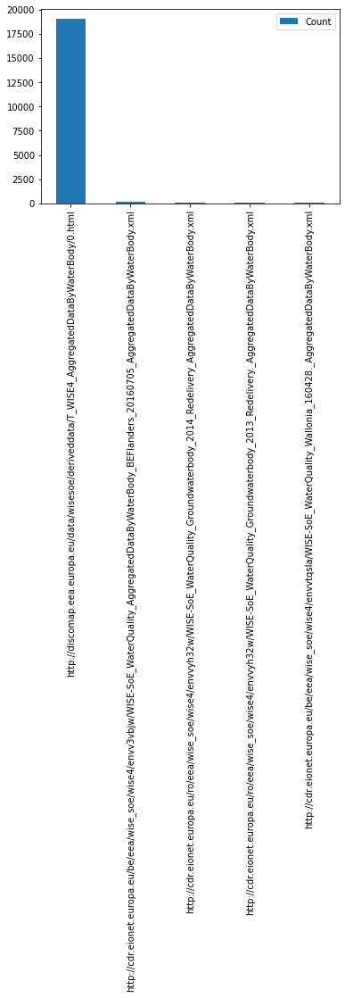

1. **What are the different dates on which life span was revised**

**Code:-**

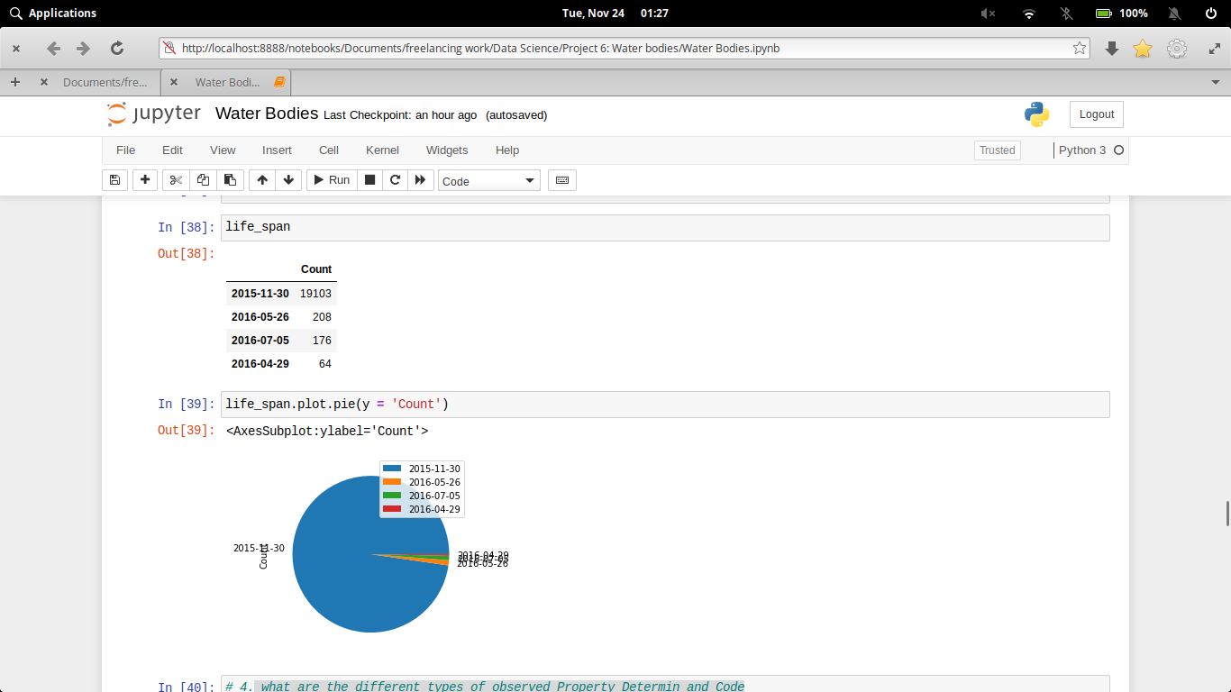

**Output:-**

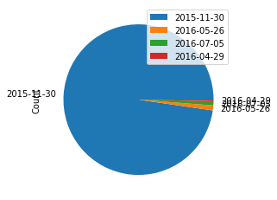

1. **What are the different types of observed Property Determin and Code**

**Code:-**

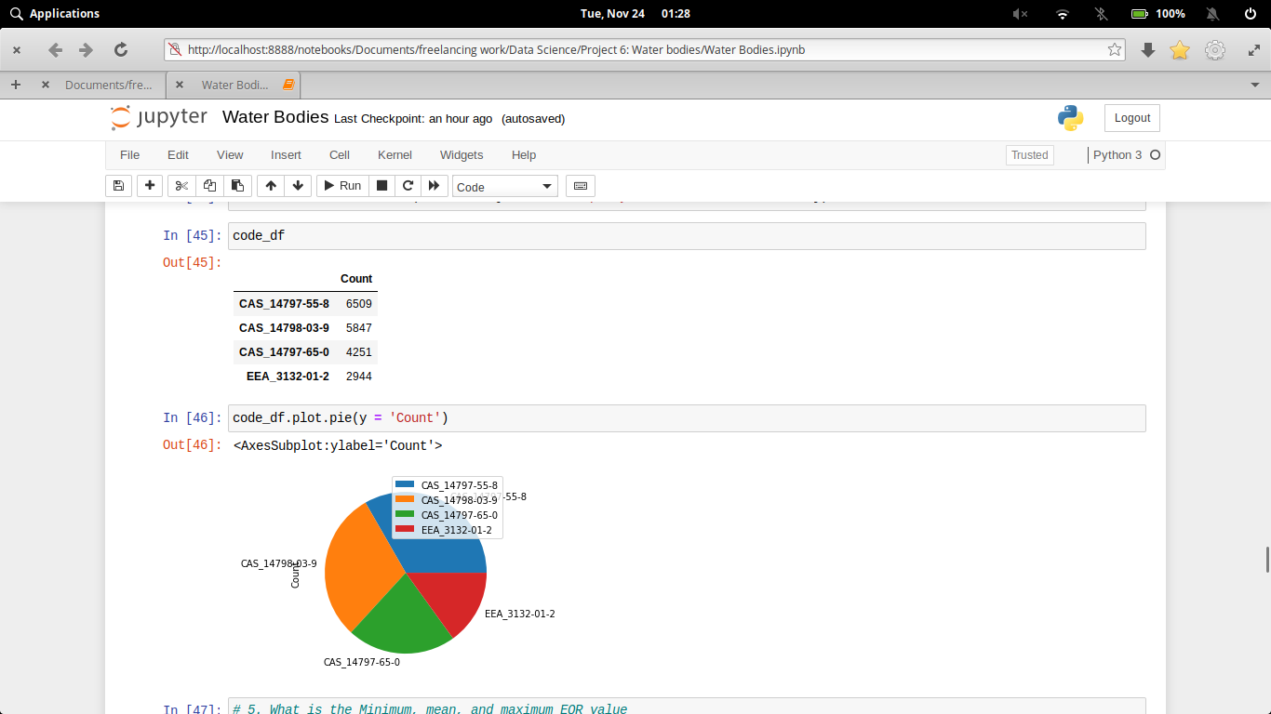

**Output:-**

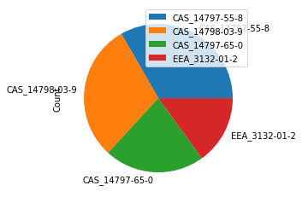

1. **What is the Minimum, mean, and maximum EQR value**

**Code:-**

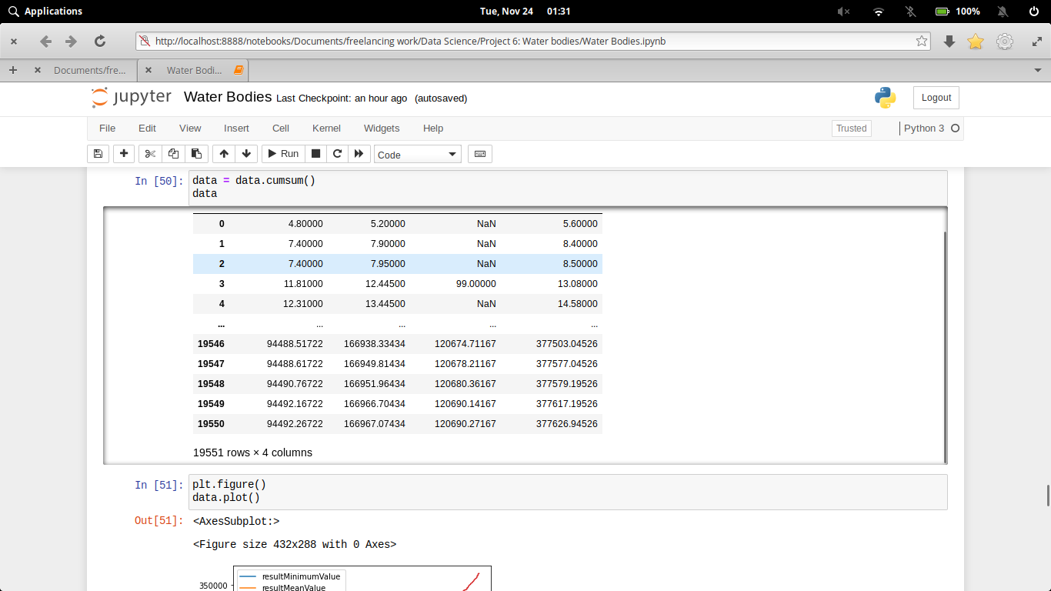

**Output:-**

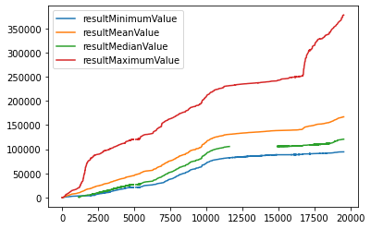

1. **Standard deviation of the EQR Values**

**Code:-**

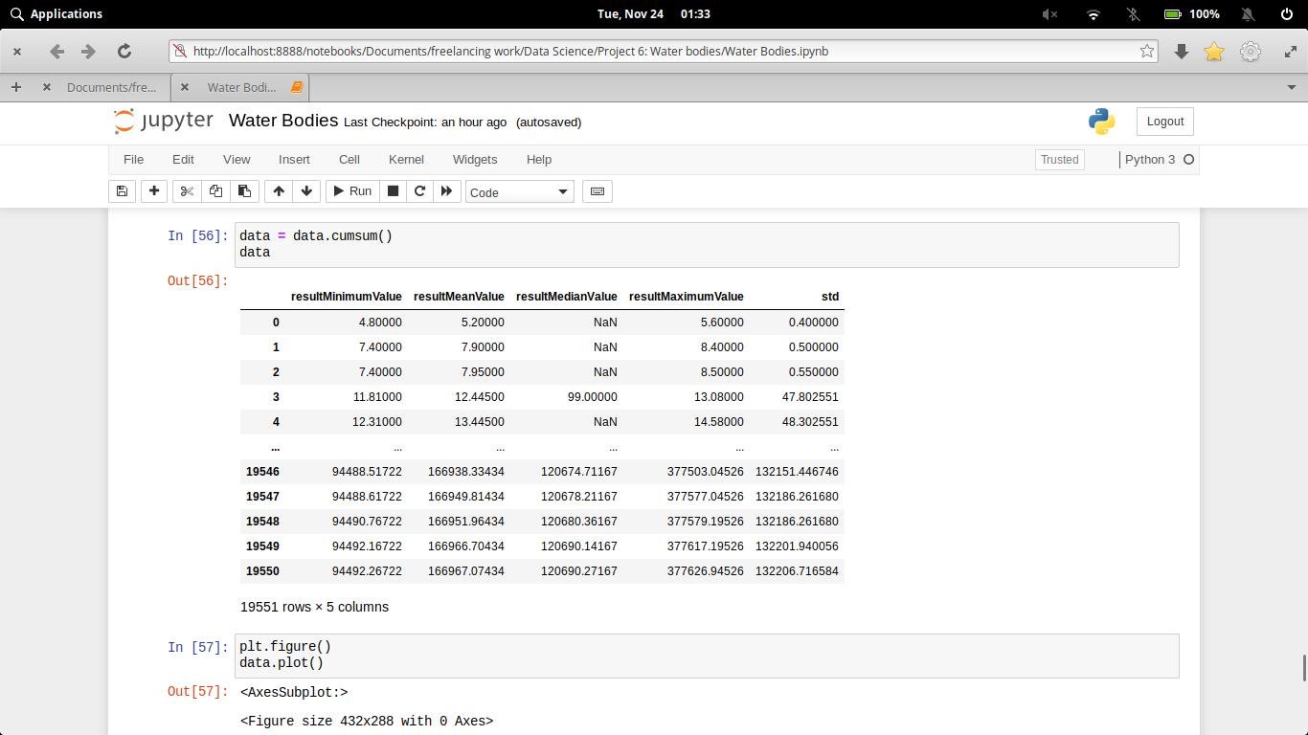

**Output:-**

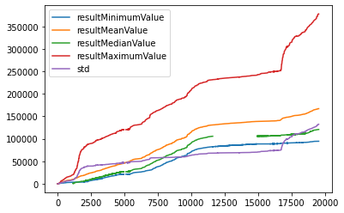

1. **EQR classification for different number of sites**

**Code:-**

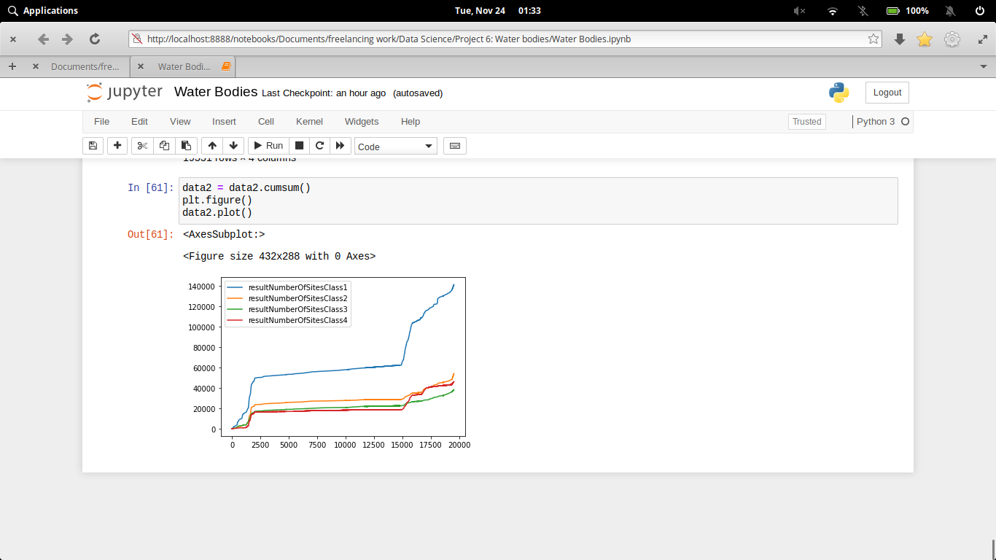

**Output:-**

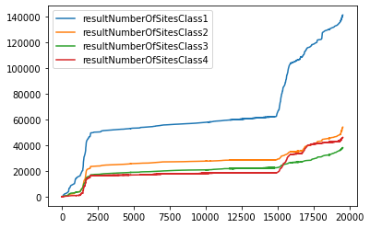

# Executive Summary

**CONCLUSION**

Clean water is significant to our health, communities, and economy. we'd like clean water upstream to possess healthy communities downstream. The health of rivers, lakes, bays, and coastal waters rely upon the streams and wetlands wherever they start. Streams and wetlands give several edges to communities by housings floodwaters, recharging groundwater provides, filtering pollution, and providing home ground for fish and life. folks rely upon clean water for his or her health: regarding 117 million Americans -- one in 3 folks – get potable from streams that were liable to pollution before the Clean Water Rule. Our cherished means of life depends on clean water: healthy ecosystems give life home ground and places to fish, paddle, surf, and swim. Our economy depends on clean water: producing, farming, tourism, recreation, energy production, and different economic sectors want clean water to perform and flourish.

**Pros and cons..**

**PROS**

* Helps maximize physical performance
* Significantly affects energy levels and brain function
* May help prevent and treat headaches

**CONS**

* NONE

# References

* https://www.healthline.com/nutrition/7-health-benefits-of-water#3.-May-help-prevent-and-treat-headaches
* <https://data.europa.eu/euodp/en/data>
* [https://en.wikipedia.org/wiki/Water_quality](https://en.wikipedia.org/wiki/COVID-19_pandemic_in_India)